**Governor Stirling Senior High School**

**2019 Year 12 Physics**

**Task 8B: Experiment – Wavelength of LED**

**Part B: DETERMINING THE WAVELENGTH OF AN UNKNOWN LED.**

**Marks: /10**

**Name: __________________________ Teacher: ________________________**

The threshold voltage at which a semiconductor LED turns on gives a measure of the bandgap or emission wavelength of the LED through the following relationship:



**The following circuit was constructed:**

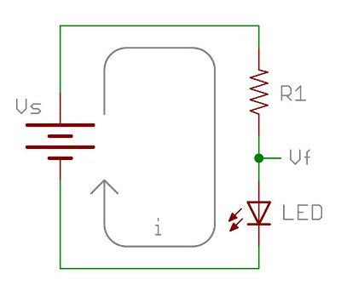

V

100 Ω resistor

50K Rheostat

A

By adjusting the rheostat, the following values of current and voltage through the LED was recorded:

|  |  |
| --- | --- |
| *V(V)* | *I(mA)* |
| 2.40 | 0.12 |
| 2.43 | 0.29 |
| 2.44 | 0.50 |
| 2.48 | 0.97 |
| 2.50 | 1.20 |

**Question 1**

Plot a suitable graph of the results. **( 4 marks)**

*USE THE GRAPH PAPER SUPPLIED.*

**Question 2 ( 3 marks)**

Determine the threshold voltage **from the graph**. **Clearly show** your method on the graph.

Vth = __________________________________________

**Question 3 ( 3 marks)**

Determine the wavelength of the LED in nanometres. Ensure your answer is expressed to the correct number of significant figures.